
Supplier of the Year 2025

This document provides key information about the Amotai Supplier Diversity Awards 2025. For more information, please contact sarah@amotai.nz.

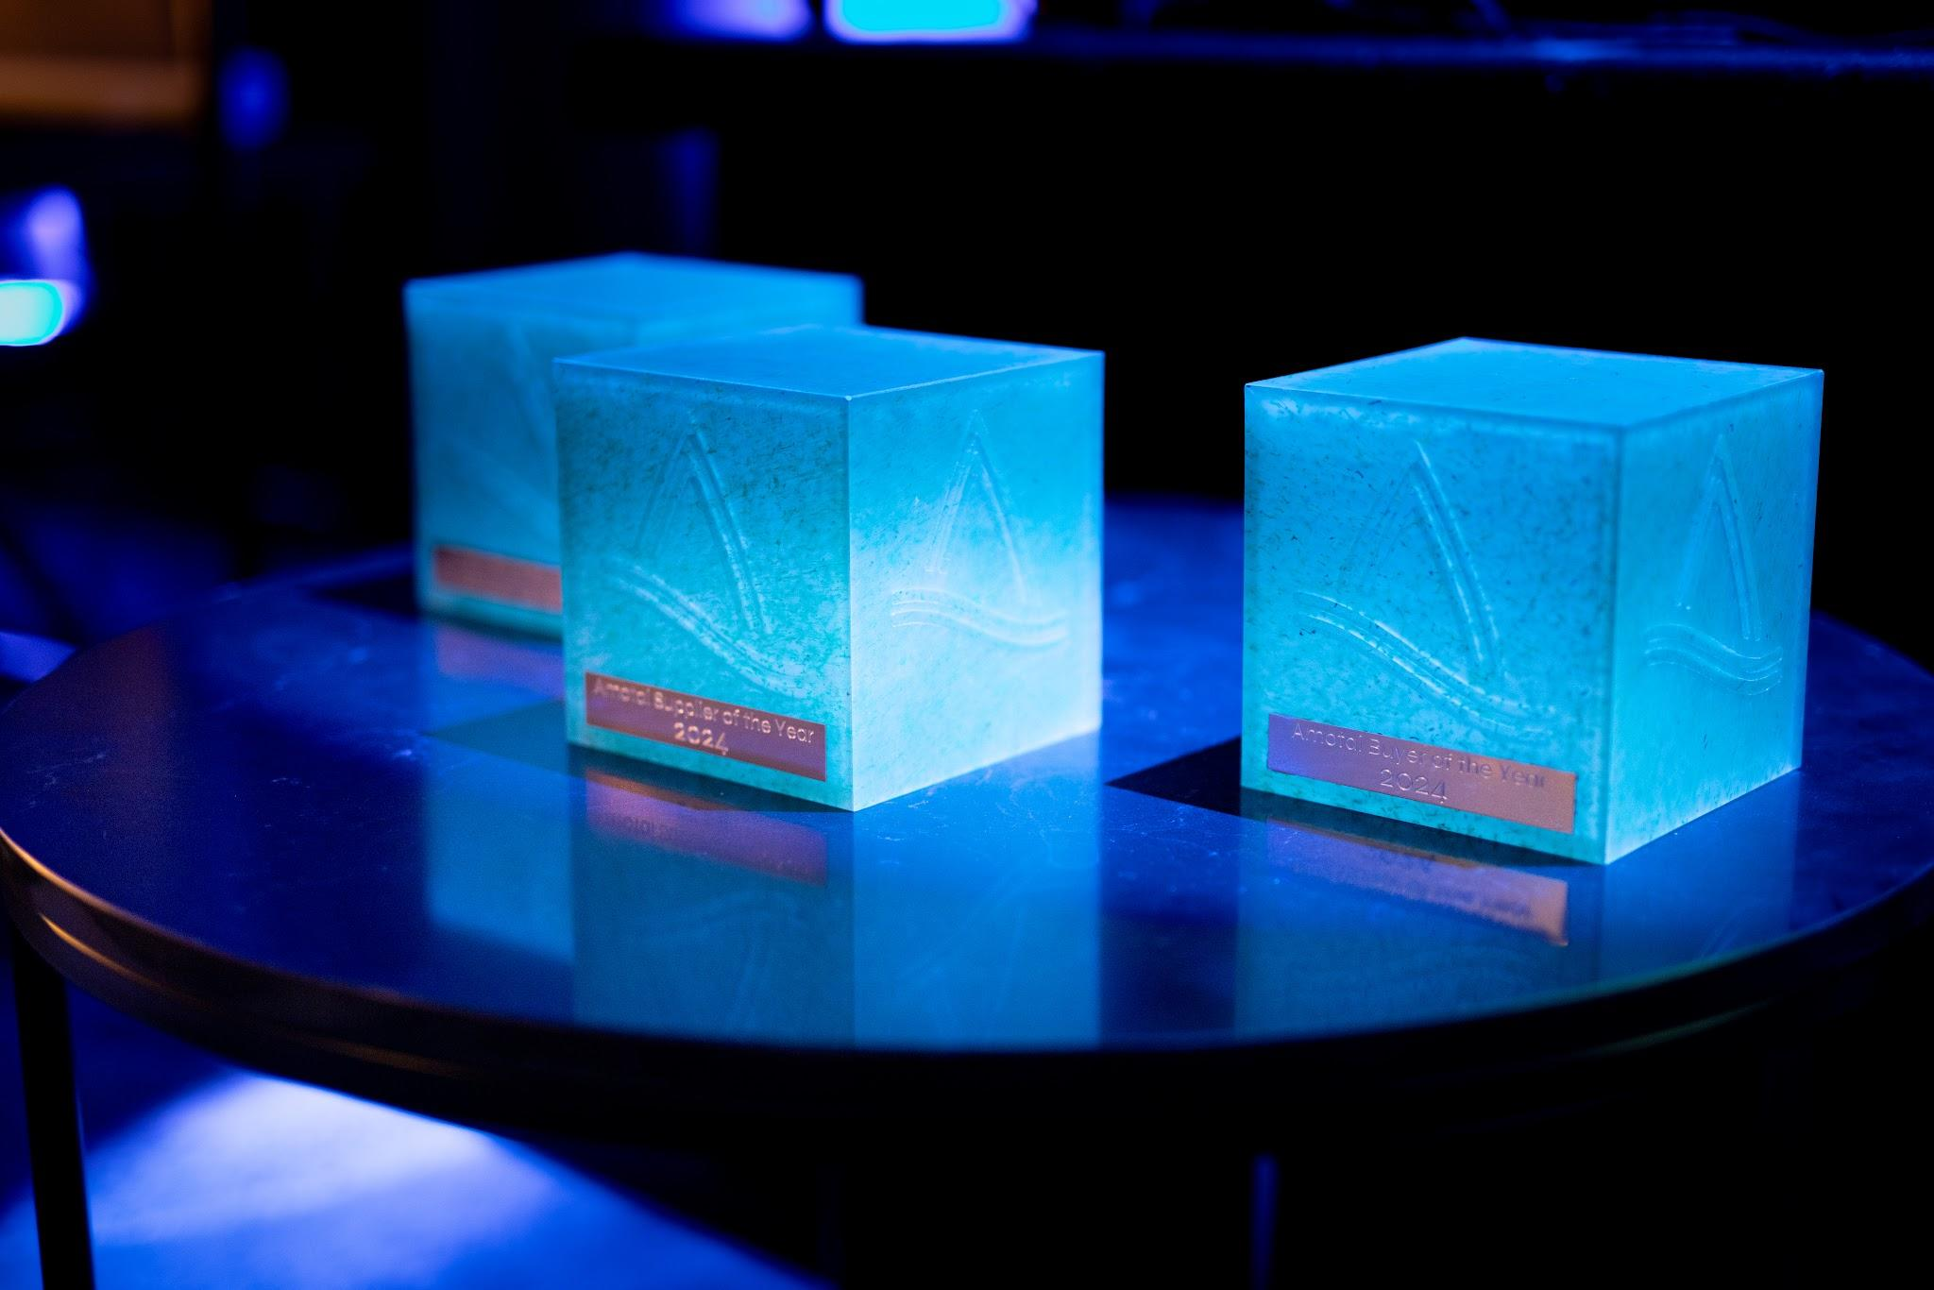

Key information

Ngā mihi for being a part of the Amotai movement in Aotearoa
This document lists the questions and word counts to assist you in preparing your submission prior to completing it online. You will also be required to upload company logos, photos and/or documents. You may start the online nomination at any time and will be able to update or amend it prior to the closing date of 1 June 2025.
Note: submissions must be completed and submitted via the online Awards platform – submissions will not be accepted via any other method. For any further information on our Supplier Diversity Award categories, https://www.cotiss.com/en-nz/amotai-awards.

Key dates
Date | Activity
27 March 2025 | Category summary released
7 April 2025 | Applications open through online platform
15 April 2025 | 7pm, online briefing for Supplier of the Year
1 June 2025 | Final deadline for submissions
21 July 2025 | Finalists announced
26 August 2025 | Winners announced at Gala Awards Dinner, Grand Millennium Hotel

Supplier of the Year - category description
This category recognises businesses that have experienced growth as a result of their involvement with Amotai and have used this growth to make a positive impact on the Māori and Pasifika economies. This impact may be evidenced through increased employment opportunities, subcontracting to Māori and/or Pasifika businesses, implementing tuakana-teina mentoring relationships, and generating other beneficial social outcomes.
The winner will have:
- Experienced growth through Amotai membership – Demonstrated clear growth in business metrics (e.g., revenue, employment, market reach) by leveraging Amotai’s network to expand operations and opportunities over the past two years.
- Demonstrated commitment to Amotai values – Actively applied Amotai’s values (manaakitanga, whanaungatanga, mana motuhake, and kairangatira) in business practices and fostered positive relationships with Māori and Pasifika suppliers.
- Supported the development of other Amotai suppliers – Played a key role in building capacity for other Amotai suppliers, providing opportunities for growth, mentoring, and subcontracting work.
- Contributed to Māori and Pasifika economic prosperity – Created opportunities for Māori and Pasifika businesses, offering subcontracting, increasing employment, and supporting their economic growth within the supply chain.

Context Questions
These questions are not scored by our judging panel but do provide them with valuable context about you / your organisation.
- Tell us about your business. 150 words max.
- When did your business become registered with Amotai?
- Why are you a part of Amotai? 150 words max.
- Tell us about your vision / inspiration for your business. 150 words max.
- Please include a brief description that outlines your business / organisation’s achievements in relation to this award category. 75 words max.
- In what ways do you think Amotai businesses are unique? 50 words max.
- How do you or your team define success when it comes to your business? 50 words max.

Criteria Questions
These questions will be scored by our judging panel and align with the four judging criteria above.
Experienced growth as a result of Amotai membership
- Tell us about your growth in the last two calendar years and how your involvement with Amotai contributed to this growth. 250 words max.
- How has being an Amotai registered business impacted your revenue or employment opportunities? 200 words max.
- How many Amotai Māori and/or Pasifika businesses did you engage with in the last two calendar years? 200 words max.
- How many Amotai buyers did you do business with in the last two calendar years? 200 words max.
Demonstrated commitment to Amotai values
- Tell us how your business has demonstrated the Amotai values of manaakitanga, whanaungatanga, mana motuhake, and kairangatira in the past year. 300 words max.
- Provide examples of how these values are reflected in your buyer and supplier relationships and business operations. 250 words max.
Supported the development of other Amotai suppliers
- How is your business supporting the development and capacity building of other Amotai suppliers? 250 words max.
- How has your business implemented tuakana-teina mentoring relationships to help other Māori and Pasifika businesses? 250 words max.
- Tell us about any specific subcontracting or collaborative projects you have undertaken with other Amotai suppliers. 250 words max.
Contributed to Māori and Pasifika economic prosperity
- Describe any other ways your business is creating a positive impact on the Māori and Pasifika economies. 300 words max.
- What key initiatives or activities does your business undertake to create social, environmental or cultural benefits? 300 words max.

Availability for promotions
We hope finalists can be in attendance with us on 26 August for the Gala Awards Dinner. Supplier finalists will be offered one complimentary Gala Awards Dinner ticket.
Finalists need to be available to meet with the Amotai team for up to 2 hours for photos and videography the week starting Monday 21 July.
The photos/video provided in the application may be used in award announcements, including but not limited to, press releases, social media posts, and other promotional materials related to the award program. By applying, nominees consent to the use of their information for these purposes.

Prepare to upload attachments
Please note: As part of this nomination, you must attach the files below when you make your nomination. The maximum size allowed is 5MB per file. The images and information you choose to upload will be used if you are selected as a finalist in your award category.
- Between one and four photos of your organisation or team. (High-resolution, at least 1MB and at least one portrait orientation.)
- A high-resolution logo of the organisation. (Vector (.ai), .eps or .jpg file type - please upload both colour AND black / white versions, AND horizontal and vertical / stacked options if possible.)

Declaration

I HEREBY CERTIFY that:
I am authorised to submit this application on behalf of [insert name of organisation].
1. The information provided in this form is complete, true and correct to the best of my knowledge.

Signature of authorised person:
Date:

FURTHER, I HEREBY ACKNOWLEDGE that I have read and understood the Amotai Privacy Policy https://amotai.nz/legal/privacy-policy and agree to the conditions set out therein. I give my consent to Amotai to collect, use and process the information provided, solely in relation to our application to the Amotai Awards. Specific information attributable to the applicant’s business will only be shared publicly by prior agreement.
I understand that if any information provided in support of this application, that is directly attributable to our organisation is to be used in announcements, media and promotions associated with the awards, I will be asked to provide specific consent to the public use of that information at a later stage.
I understand that my consent does not preclude the existence of other criteria for lawful processing of personal data, and does not waive any of my rights under the New Zealand Privacy Principles contained in the Privacy Act 1993, and the Privacy Act 2020 (together, the Privacy Act) and other applicable laws.

Signature of authorised person:
Date:

Good Luck!
Nominations close at 11:59pm on Sunday 1 June 2025.
Finalists will be announced by 21 July 2025.
Winners will be announced at the Amotai Gala Awards Dinner on Tuesday 26th August at Grand Millennium Hotel.
If you have any questions or feedback, please email sarah@amotai.nz.

