
Buyer of the Year 2025

This document provides key information about the Amotai Supplier Diversity Awards 2025. For more information, please contact sarah@amotai.nz.

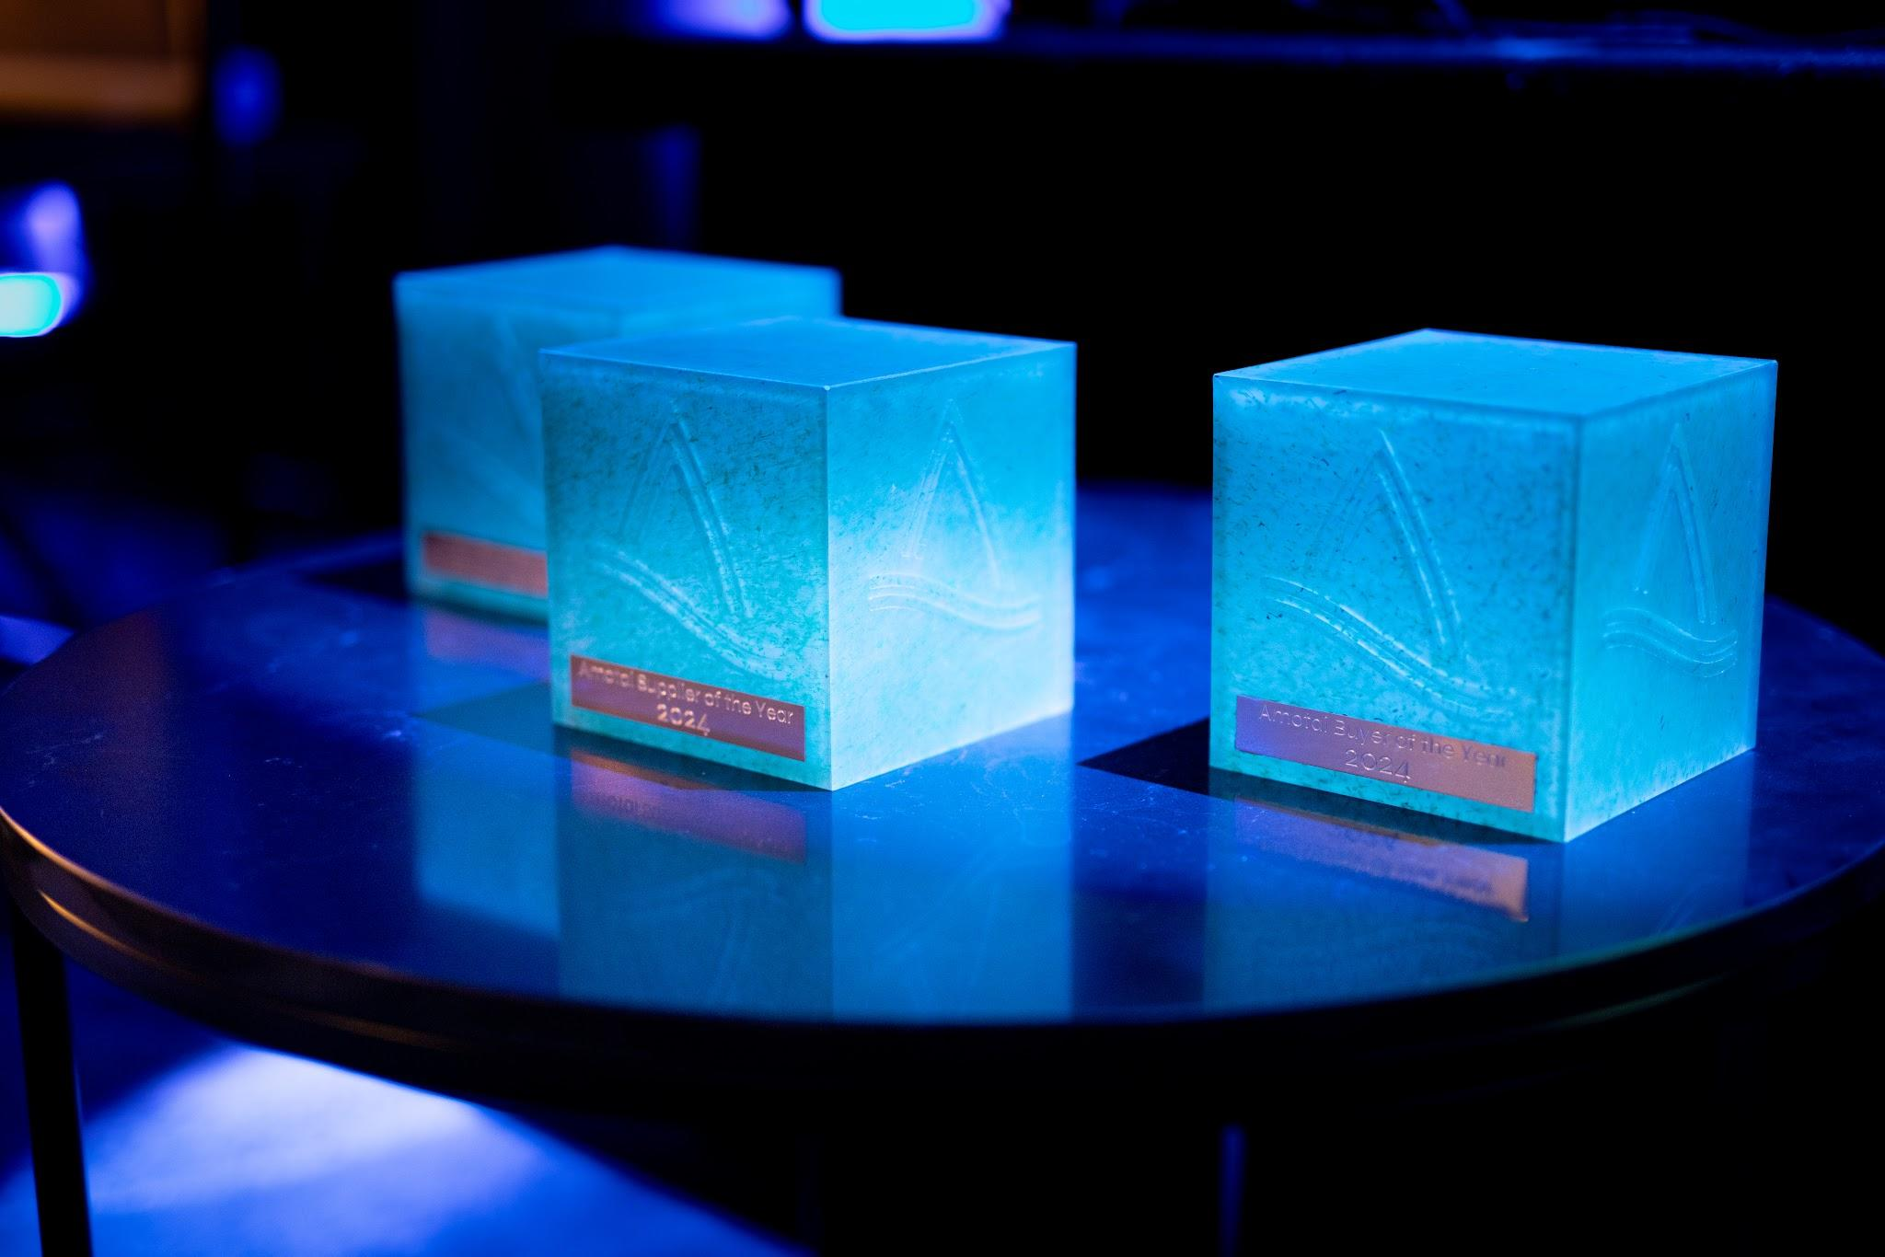

Key information

Ngā mihi for being a part of the Amotai movement in Aotearoa
This document lists the questions and word counts to assist you in preparing your submission prior to completing it online. You will also be required to upload company logos, photos and/or documents. You may start the online nomination at any time and will be able to update or amend it prior to the closing date of 1 June 2025.
Note: submissions must be completed and submitted via the online Awards platform – submissions will not be accepted via any other method. For any further information on our Supplier Diversity Award categories, https://www.cotiss.com/en-nz/amotai-awards.

Key dates
Date | Activity
27 March 2025 | Category summary released
7 April 2025 | Applications open through online platform
1 June 2025 | Final deadline for submissions
21 July 2025 | Finalists announced
26 August 2025 | Winners announced at Gala Awards Dinner, Grand Millennium Hotel

Buyer of the Year - category description
This award recognises a buyer member that has demonstrated exceptional commitment, engagement, and leadership in supplier diversity. It focuses on the organisation’s overall improvements in supplier diversity, not a single project.
Eligibility: The buyer must have completed Tere ki Tai – Amotai’s buyer maturity matrix and be actively working on their action plan to be eligible for this award.

Judging criteria
The winner will have:
Demonstrated leadership in supplier diversity – Actively advocating for the inclusion of Māori and Pasifika businesses and embedding supplier diversity within business operations.
Shown measurable impact and growth – Achieved an increase in engagement with Māori and Pasifika suppliers, with sustainable growth in procurement spend as a percentage of total spend.
Created opportunities and supported supplier development – Identified new opportunities for Māori and Pasifika businesses and supported their capability and growth through supplier development initiatives.

Context Questions
These questions are not scored by our judging panel but do provide them with valuable context about you / your organisation.

- Tell us about your organisation, department or agency. 150 words max.
- How long has your organisation been a member of Amotai?
- Tell us about your vision or inspiration for working with Māori and Pasifika businesses. 150 words max.
- Please include a brief description that outlines your business / organisation’s achievements in relation to this award category. 75 words max.
- In what ways do you think Māori and Pasifika businesses are unique? 50 words max.
- What motivates you or your team working in the supplier diversity space? 50 words max.

Criteria Questions
These questions will be scored by our judging panel and align with the judging criteria above.
Commitment, Engagement, and Leadership
- Describe how your organisation has demonstrated commitment, engagement, and leadership in supplier diversity. 200 words max.
- What key activities has your organisation undertaken to create a sustained shift in supplier diversity efforts? Provide specific examples of how your organisation has led by example in supplier diversity, internally and externally. 300 words max.
- How has your organisation shown leadership in promoting supplier diversity and advocating for the inclusion of Māori and Pasifika businesses in procurement processes? 250 words max.
- What challenges have you faced in your supplier diversity efforts, and how have you addressed them? 250 words max.
Measurable Growth & Impact
- How many Amotai Māori and/or Pasifika businesses did your organisation contract with in 2024? How many Amotai Māori and/or Pasifika businesses did your organisation contract with in 2023?
- What percentage of your supply chain was Amotai Māori and Pasifika businesses in 2024?
- What percentage of your total procurement spend was with Amotai Māori and Pasifika businesses in 2024? What percentage of your total procurement spend was with Amotai Māori and Pasifika businesses in 2023?
- Beyond spend, describe the measurable impact of your supplier diversity efforts on Māori and Pasifika businesses. 350 words max
Supplier Development & Capacity Building
- How is your organisation identifying or creating opportunities to engage new Māori and Pasifika businesses in your procurement processes? 200 words max.
- How is your organisation helping Amotai suppliers to grow their capabilities and scale their businesses? 200 words max.
- What specific initiatives or long-term strategies does your organisation have in place to strengthen the capacity of the Māori and Pasifika suppliers you engage with? 200 words

References
Nominees must provide at least one reference from an Amotai supplier to support the claims made in their application. This reference will be used to validate the nominee's achievements and contributions.
Name:
Email:
Phone Number:

Availability for promotions
We hope finalists can be in attendance with us on 26 August for the Gala Awards Dinner. Supplier finalists will be offered one complimentary Gala Awards Dinner ticket.
Finalists need to be available to meet with the Amotai team for up to 2 hours for photos and videography the week starting Monday 21 July.
The photos/video provided in the application may be used in award announcements, including but not limited to, press releases, social media posts, and other promotional materials related to the award program. By applying, nominees consent to the use of their information for these purposes.

Prepare to upload attachments
Please note: As part of this nomination, you must attach the files below when you make your nomination. The maximum size allowed is 5MB per file. The images and information you choose to upload will be used if you are selected as a finalist in your award category.
- Between one and four photos of your organisation or team. (High-resolution, at least 1MB and at least one portrait orientation.)
- A high-resolution logo of the organisation. (Vector (.ai), .eps or .jpg file type - please upload both colour AND black / white versions, AND horizontal and vertical / stacked options if possible.)

Declaration

I HEREBY CERTIFY that:
I am authorised to submit this application on behalf of [insert name of organisation].
1. The information provided in this form is complete, true and correct to the best of my knowledge.

Signature of authorised person:
Date:

FURTHER, I HEREBY ACKNOWLEDGE that I have read and understood the Amotai Privacy Policy https://amotai.nz/legal/privacy-policy and agree to the conditions set out therein. I give my consent to Amotai to collect, use and process the information provided, solely in relation to our application to the Amotai Awards. Specific information attributable to the applicant’s business will only be shared publicly by prior agreement.
I understand that if any information provided in support of this application, that is directly attributable to our organisation is to be used in announcements, media and promotions associated with the awards, I will be asked to provide specific consent to the public use of that information at a later stage.
I understand that my consent does not preclude the existence of other criteria for lawful processing of personal data, and does not waive any of my rights under the New Zealand Privacy Principles contained in the Privacy Act 1993, and the Privacy Act 2020 (together, the Privacy Act) and other applicable laws.

Signature of authorised person:
Date:

Good Luck!
Nominations close at 11:59pm on Sunday 1 June 2025.
Finalists will be announced by 21 July 2025.
Winners will be announced at the Amotai Gala Awards Dinner on Tuesday 26th August at Grand Millennium Hotel.
If you have any questions or feedback, please email sarah@amotai.nz.

